Bank Management System – Mini Project Report
Database Design, ER Diagram, and SQL Implementation
Database: BankDB
Submission Date: August 20, 2025

Abstract
This project presents a relational database design for a Bank Management System. It models core entities such as Customers, Accounts, Transactions, and Loans, and includes a trigger to auto-update account balances and a stored procedure for money transfers. The design supports common banking operations while maintaining referential integrity and auditability.

Objectives
- Store customer and account information reliably.
- Record transactions with timestamps for traceability.
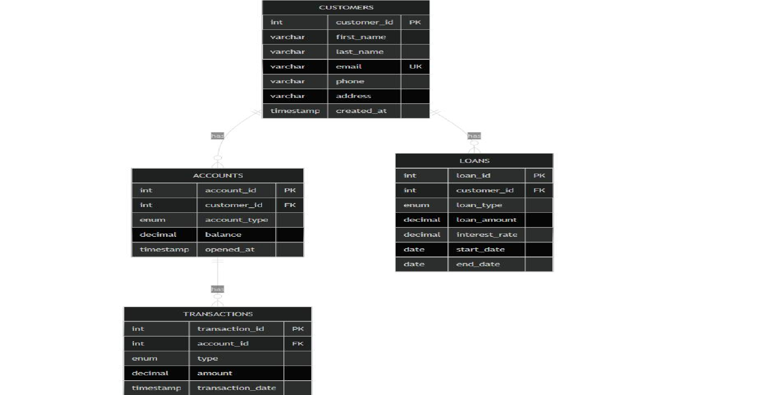
- Support loan management with amounts, interest, and duration.
- Enforce integrity via primary/foreign keys and cascades.
- Automate business logic using triggers and stored procedures.

Scope
The scope covers schema design, ER modeling, and key SQL code elements (DDL, DML, trigger, and procedure). Authentication, teller/banking UI, and advanced risk/credit scoring are out of scope for this submission.
Entity–Relationship (ER) Diagram
The ER diagram below illustrates the relationships among the core entities.

Schema Design

Customers
Stores customer personal details.
Column | Data Type / Constraints
customer_id | INT, PK, AUTO_INCREMENT
first_name | VARCHAR(50)
last_name | VARCHAR(50)
dob | DATE
email | VARCHAR(100), UNIQUE
phone | VARCHAR(15)
address | VARCHAR(255)
created_at | TIMESTAMP, DEFAULT CURRENT_TIMESTAMP
Notes: Primary Key: customer_id; email is UNIQUE

Accounts
Bank accounts owned by customers.
Column | Data Type / Constraints
account_id | INT, PK, AUTO_INCREMENT
customer_id | INT, FK -> Customers.customer_id ON DELETE CASCADE ON UPDATE CASCADE
account_type | ENUM('Savings','Current','Fixed Deposit')
balance | DECIMAL(12,2) DEFAULT 0.00 (later ALTER to DECIMAL(15,2))
opened_at | TIMESTAMP, DEFAULT CURRENT_TIMESTAMP
Notes: Primary Key: account_id; Foreign Key: customer_id -> Customers.customer_id (CASCADE)

Transactions
Records deposits/withdrawals/transfers per account.
Column | Data Type / Constraints
transaction_id | INT, PK, AUTO_INCREMENT
account_id | INT, FK -> Accounts.account_id ON DELETE  CASCADE ON UPDATE CASCADE
type | ENUM('Deposit','Withdrawal','Transfer')
amount | DECIMAL(12,2)
transaction_date | TIMESTAMP, DEFAULT CURRENT_TIMESTAMP
Notes: Primary Key: transaction_id; Foreign Key: account_id -> Accounts.account_id (CASCADE)

Loans
Loan details associated with customers.
Column | Data Type / Constraints
loan_id | INT, PK, AUTO_INCREMENT
customer_id | INT, FK -> Customers.customer_id ON DELETE CASCADE
loan_type | ENUM('Home','Car','Personal','Education')
loan_amount | DECIMAL(12,2)
interest_rate | DECIMAL(5,2)
start_date | DATE
end_date | DATE
Notes: Primary Key: loan_id; Foreign Key: customer_id -> Customers.customer_id (CASCADE)

Relationships & Cardinality
Customers (1) ——— (N) Accounts via Accounts.customer_id
Customers (1) ——— (N) Loans via Loans.customer_id
Accounts (1) ——— (N) Transactions via Transactions.account_id

Business Logic (Trigger & Procedure)
- Trigger: update_balance_after_transaction – After inserting a row into Transactions, it automatically increases or decreases the corresponding Accounts.balance based on the transaction type.
- Procedure: TransferMoney(sender_id, receiver_id, amount) – Inserts two transactions: a withdrawal on the sender account and a deposit on the receiver account.

Sample Operations & Queries
The project includes sample inserts for Customers, Accounts, Transactions, and Loans; basic SELECT statements (filters, ordering, aggregates), and joins (INNER/LEFT/RIGHT).

Normalization Rationale
- 1NF: All attributes are atomic (no repeating groups).
- 2NF: Non-key attributes depend on the full key in each table (single-attribute PKs used). • 3NF: No transitive dependency on non-key attributes (e.g., in Customers, email/phone/address depend on customer_id only).

Data Integrity & Constraints
Primary keys uniquely identify rows; foreign keys enforce referential integrity with cascades. ENUMs limit allowable values for account and loan types. UNIQUE constraint on email avoids duplicates.

Known Issues & Suggested Fixes
- The script attempts to add 'dob' twice (once in CREATE TABLE and again via ALTER). Remove the ALTER that re-adds dob.
- An INSERT into Customers references a 'city' column that does not exist; replace with 'address' or add a 'city' column.
- A WHERE clause uses loan_type = 'Home Loan' but ENUM values are
'Home','Car','Personal','Education'; use 'Home'.
- SELF JOIN example also references 'city'; use 'address' or add a 'city' column.
- Balance column is altered to DECIMAL(15,2); ensure consistent definition across DDL and documentation.

Testing & Future Enhancements
Basic testing can be performed by inserting accounts and transactions to verify the trigger updates balance correctly. Future enhancements could include:
- Add branch and employee modules.
- Add transaction rollback/consistency checks in the transfer procedure (e.g., START TRANSACTION, COMMIT/ROLLBACK).
- Add indexes on frequently queried columns.
- Add audit tables for security and compliance.

Conclusion
The Bank Management System schema is normalized, enforces integrity with keys and constraints, and includes basic automation. It is suitable as a compact, demonstrable college project.

